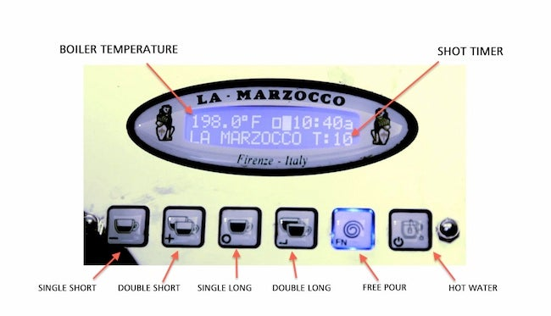

**Guide to Making Various Coffee Drinks (Metric System)**

**Espresso Machine Operation**

* **Single Shot**: 30 ml of espresso.
* **Double Shot**: 60 ml of espresso.
* **Single Long (Lungo)**: 60 ml of espresso.
* **Double Long (Double Lungo)**: 120 ml of espresso.

**Making Different Coffee and Tea Drinks**

**Espresso**

1. **Measure Coffee Grounds**:
   * Use 7-9 grams for a single shot or 14-18 grams for a double shot.
2. **Pull the Shot**:
   * Brew the espresso shot according to the desired strength and volume.

**Latte**

1. **Prepare Espresso**:
   * Pull a single shot of espresso (30 ml) into a cup.
2. **Steam Milk**:
   * Steam 200 ml of milk to 65°C, creating a creamy microfoam.
3. **Combine**:
   * Pour the steamed milk into the espresso, holding back the foam with a spoon. Top with a small amount of foam.

**Cappuccino**

1. **Prepare Espresso**:
   * Pull a single shot of espresso (30 ml) into a cup.
2. **Steam Milk**:
   * Steam 150 ml of milk to 65°C, creating a generous amount of foam.
3. **Combine**:
   * Pour the steamed milk and foam over the espresso, aiming for equal parts espresso, milk, and foam.

**Americano**

1. **Prepare Espresso**:
   * Pull a single shot of espresso (30 ml).
2. **Add Water**:
   * Add 90 ml of hot water to the espresso to reach the desired strength.

**Mocha**

1. **Mix Ingredients**:
   * Combine 20 ml of chocolate syrup with a single shot of espresso (30 ml) in a cup.
2. **Steam Milk**:
   * Steam 200 ml of milk to 65°C.
3. **Combine**:
   * Pour the steamed milk into the chocolate-espresso mixture.
4. **Optional Toppings**:
   * Top with whipped cream and drizzle with additional chocolate syrup if desired.

**Flat White**

1. **Prepare Espresso**:
   * Pull a double shot of espresso (60 ml).
2. **Steam Milk**:
   * Steam 150 ml of milk to 65°C, creating a fine microfoam.
3. **Combine**:
   * Pour the steamed milk over the espresso, ensuring a smooth texture with a thin layer of microfoam on top.

**Long Black**

1. **Add Hot Water**:
   * Fill a cup with 90-120 ml of hot water.
2. **Prepare Espresso**:
   * Pull a double shot of espresso (60 ml).
3. **Combine**:
   * Pour the espresso over the hot water to preserve the crema.

**Short Black**

1. **Prepare Espresso**:
   * Pull a single shot of espresso (30 ml) into a small cup.

**Chai Latte**

1. **Mix Ingredients**:
   * Combine 100 ml of chai concentrate with 100 ml of milk.
2. **Steam Mixture**:
   * Steam the chai-milk mixture to 65°C.
3. **Serve**:
   * Pour into a cup and optionally sprinkle with cinnamon on top.

**Dirty Chai**

1. **Prepare Espresso**:
   * Pull a single shot of espresso (30 ml).
2. **Prepare Chai Latte**:
   * Follow the steps for a chai latte.
3. **Combine**:
   * Add the espresso shot to the chai latte and mix well.

**Sticky Chai**

1. **Brew Tea**:
   * Brew sticky chai tea (loose leaf tea with honey) in a teapot.
2. **Steam Milk**:
   * Steam milk to 65°C.
3. **Combine**:
   * Mix the brewed tea with the steamed milk.
4. **Optional Sweetening**:
   * Add additional honey for sweetness if desired.